**CS323 Documentation**

**1. Problem Statement**

The first assignment is to write a lexical analyzer. We are to build our entire lexer using a FSM, or build using at least FSMs for identifier, integer and real (the rest can be written ad-hoc).

**2. Design of your program**

The program uses the class data structure that reads in input.txt and output.txt and does basic error checking if it can’t open the file.

First it gets a character, then it goes into the main do-while loop and initializes the next token to 0, analyzes the character, and then prints it to the output.txt. Once it reaches the end of the file, it closes the document.

When it gets a character, it finds out if it’s a number, punctuation, space, or letter. If it isn’t one of these then it’s the end of the file.

RE for identifiers = L(L|D*|$)*

RE for integer and float = D*(D|.)D*

Here is the NFSM using Thompson’s Method

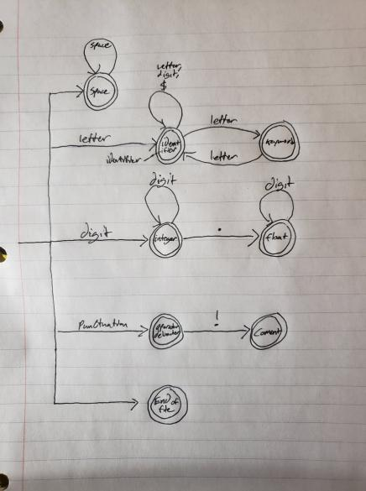

The FSM has been implemented for integer or real numbers.

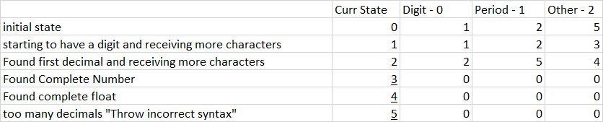

**3. Any Limitation**

None

**4. Any shortcomings**

If the input.txt file ends with a number, then it will go into an infinite loop.